Steps to align code in STS

1. Right click in Package Explorer -> import -> Preferences
2. Browse and provide preferences file “STS_save_preference_settings.epf” from AppConfigFiles git repository (master branch)
3. Refer screenshot. Click on finish

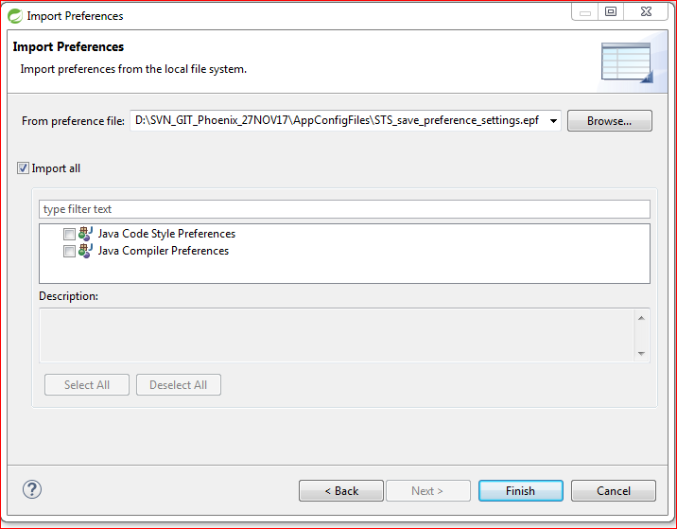

1. Apply preferences to all projects in workspace –

Window -> Preferences -> search with “save”

Select “java -> editor -> Save Actions”

Refer screenshot –

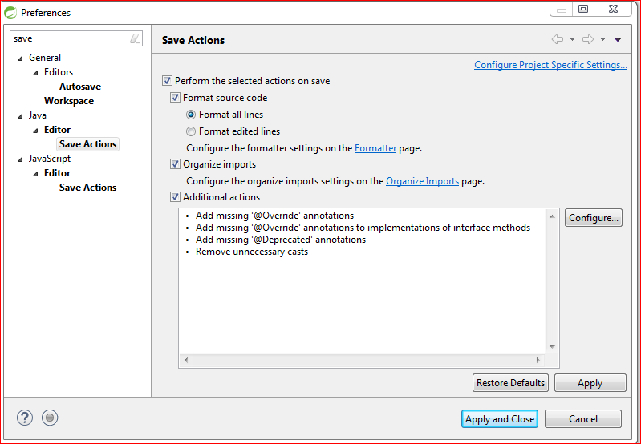

Select checkboxes -

1. Perform the selected actions on save
2. Format source code
3. Organize imports
4. Additional actions

Click on Formatter to navigate to active profile verify “Phoenix” profile is selected as per screenshot -

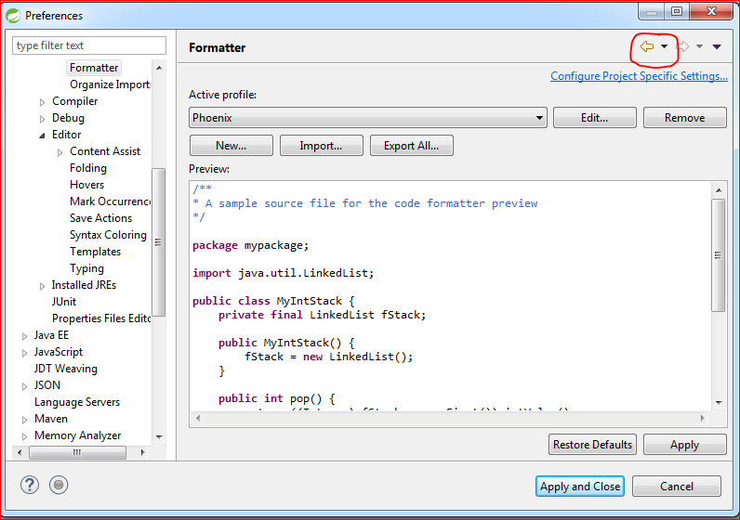

1. Click on back button highlighted in red circle to go back to previous screen
2. Click on Configure button under “Additional actions”

Follow steps to add additional actions as per screenshot-

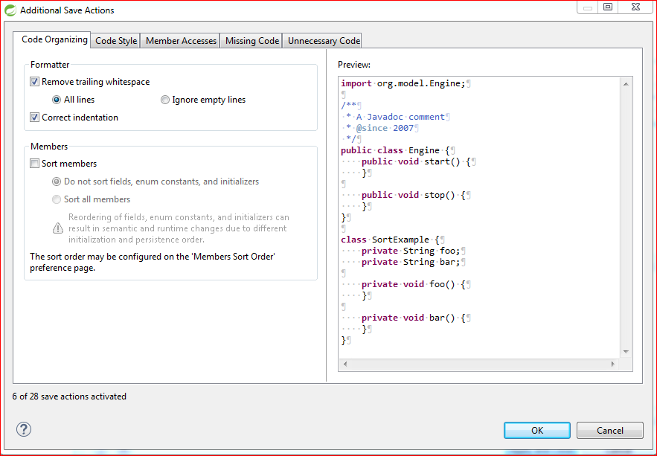

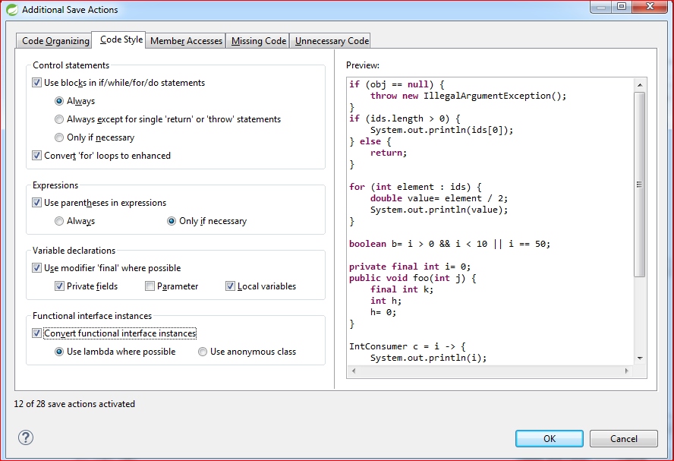



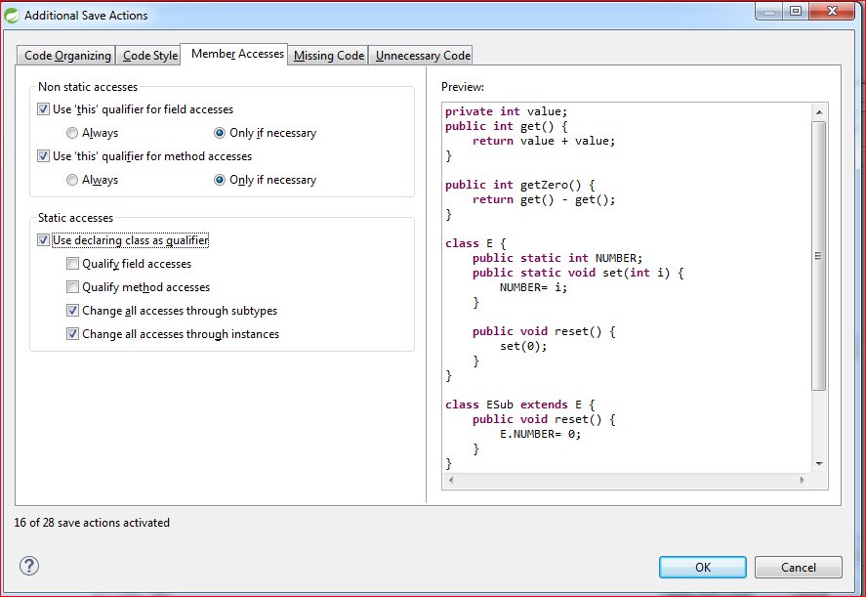

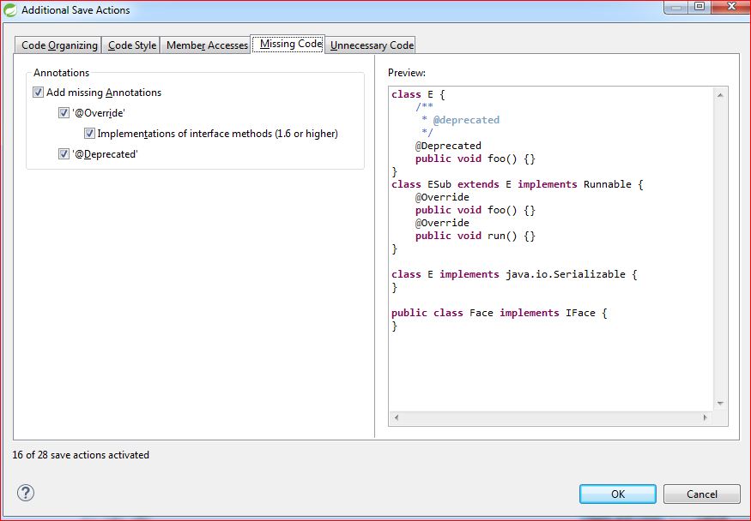

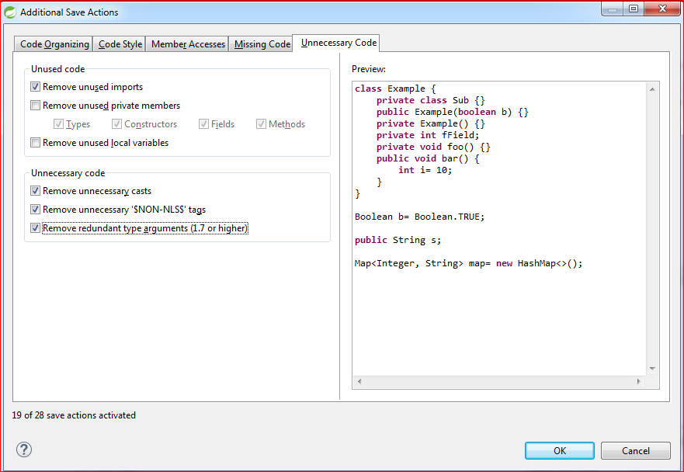

Note: additional_STS_save_preference_settings.txt will show stesp configured via above action in “save actions” window.